1.

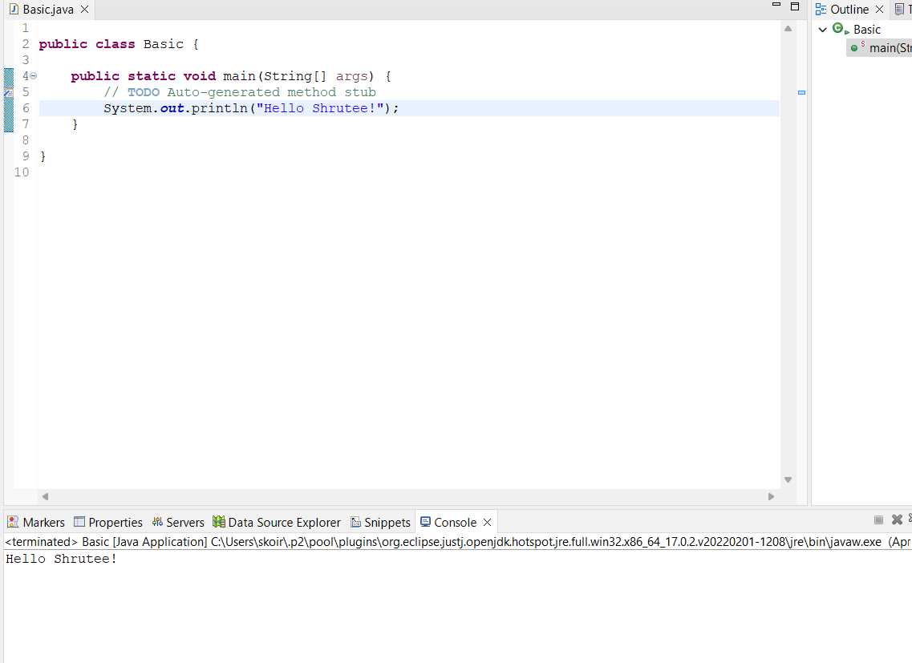

2.

3.

4.

